Additional file 1. Supplementary material
Proteomic analysis identifies of markers of exposure to cadmium sulphide quantum dots (CdS QDs)
Valentina Gallo,¹ Vaibhav Srivastava,² Vincent Bulone,^{2,3,} Andrea Zappettini,⁴ Marco Villani,⁴ Nelson Marmiroli, ^{1,5} Marta Marmiroli ^{1 *}.
¹ Department of Chemistry, Life Sciences and Environmental Sustainability, University of Parma, 4 Parma, Italy
² Royal Institute of Technology (KTH), Division of Glycoscience, School of Engineering Sciences in Chemistry, Biotechnology and Health, AlbaNova University Center, SE-106 91 Stockholm, Sweden
³ ARC Centre of Excellence in Plant Cell Walls and School of Agriculture, Food and Wine, The University of Adelaide, 5064 Urrbrae, South Australia, Australia.
⁴ Institute of Materials for Electronics and Magnetism (IMEM), National Research Council (CNR), 6 Parma, Italy
⁵ The Italian National Interuniversity Consortium for Environmental Sciences (CINSA), Parma, Italy
List of Supplementary material:
S.1; S.2. Supplementary methods related to nanoparticles synthesis and characterization
Figure S1. HRTEM image of ligand-free QDs assembly and X-ray diffraction pattern
Figure S2. (A) ESEM image of the CdS QDs agglomerates. (B) X ray spectra corresponding to the red rectangle in figure S2A.
Figure S3. 2D-gel electrophoresis for the 9 h treatments.
Figure S4. Venn diagram showing the number of unique proteins identified and quantified from the iTRAQ analysis of two biological replicates (BR1 and BR2) for the 9 h treatment corresponding to the four developmental stages.
Figure S5. Venn diagram showing the number of unique proteins identified and quantified from the iTRAQ analysis of two biological replicates (BR1 and BR2) for the 24 h treatment corresponding to the four developmental stages.
Figure S6. Comparison of the number of proteins isolated and identified with iTRAQ and 2D-PAGE for the 9 h treatment. The Venn diagram (A) depicts the numbers of isolated proteins. The Venn diagram (B) depicts the numbers of significantly modulated proteins.
Figure S7. Proteins differentially regulated in the four conditions.
Figure S8. Gene Ontology slim, enrichment analyses
Figure S9. Flow cytometry measurements. Yeast were stained with DCFHDA and PI and detected by flow cytometry after 30 min incubation in the dark. The lateral axis represents the fluorescence of DCFH while vertical axis indicates PI intensity of detected cells.

S.1. CdS QDs synthesis and characterization
Uncoated Cadmium Sulfide Quantum Dots (CdS QDs) were synthesized by IMEM-CNR (Parma, Italy), following the method of Villani et al. (2012). The CdS QDs were characterized in deionized water by transmission electron microscopy (TEM) (Hitachi HT7700, Hitachi High Technologies America, Pleasanton, CA) (Pasquali et al., 2017). Average static diameter was 5 nm, and the crystal structure was that of wurtzite (ZnS) with approximately 78% Cd. Average particle size (dh) of the aggregates (measured with DLS) and zeta potential (ζ) in ddH₂O were estimated in deionized water at 178.7 nm and +15.0 mV, respectively; in YPD the values were 545 nm and -11 mV respectively (Zetasizer Nano Series ZS90, Malvern Instruments, Malvern, UK). Additional particle characterization data is provided in the Supplementary Materials, and Figures S1-S2.
S.2. Synthesis and characterization of CdS QDs
Cadmium acetate (99%), N, N-dimethyl formamide (99%) and thiourea (99.5%) were all purchased from Sigma Aldrich (Saint Louis, MO, USA) and used without further puriﬁcation. The method used to synthesize CdS QDs followed Villani et al. (2012), and the synthesis was performed by IMEM-CNR (Parma, Italy). X-ray diffraction was performed using an ARL-X’Tra device (Thermo Fisher Scientific, 81 Wyman Street, Waltham, MA USA). A ﬁeld emission high resolution (Scherzer resolution of ~0.19 nm) JEM-2200 FS transmission electron microscope (JEOL ltd., 3-1-2 Musashino, Akishima, Tokyo, JAPAN) operating at 200 kV, was used to examine the structure of the CdS QDs. The diffraction pattern and HRTEM investigation of the CdS QDs are reported in Fig. S1A, B, C.
An ESEM Quanta 250FEG, FEI with Bruker QUANTAX EDS XFlash® 6T detector series and ESPRIT 2 analytical methods interface (FEI company, 5350 NE Dawson Creek Drive Hillsboro, Oregon 97124 USA, Bruker, Am Studio 2D, 12489 Berlin, Germany) was utilized to determine CdS quantum dots group morphology and elemental content. Single drops of 1 ml containing 80 mg/l of CdS Quantum dots were left to dry on SEM stub covered with carbon tape in a protected environment. Seven stubs were analyzed during one round of experiments. Working parameters for SE imaging e X-ray spectra acquisition were as follows. Pressure: 70 Pa, working distance: 9.9 mm, acceleration voltage: 20KeV. Figure S2A, B represents CdS QDs at different magnifications, along with their EDX spectra (Marmiroli et al., 2020).
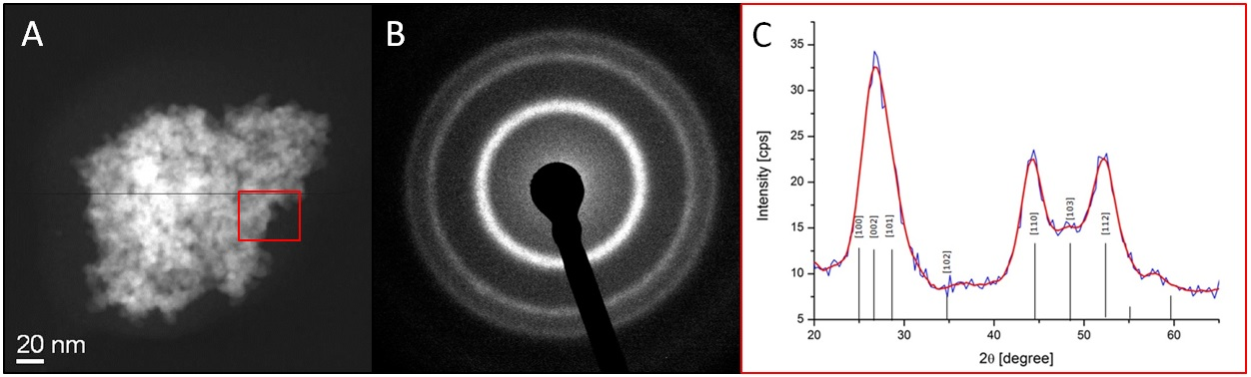
Figure S1. HRTEM image of ligand-free QDs assembly. (A) A CdS QDs aggregate upon solvent evaporation. (B) Fourier transform analysis of the whole HRTEM image. (C) X-ray diffraction pattern. Diffraction pattern obtained from the red rectangle: the diffraction rings related to the lower diffraction index are observable related to the hexagonal structure of the CdS QDs. From inside to outside are observable the triplet 100,002, 101; the doublet 110 e 103; and the singlet112. According to the diffraction pattern the estimated dimensions of the QDs are between 4 and 5 nm.

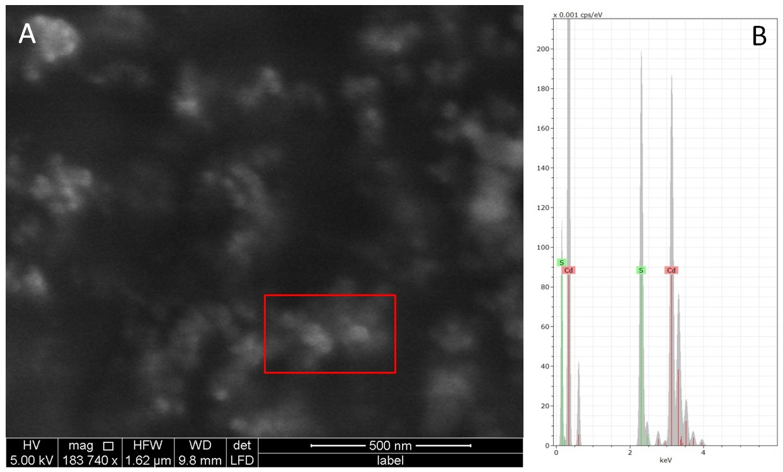
Figure S2. (A) ESEM image of the CdS QDs agglomerates. (B) X ray spectra corresponding to the red rectangle in figure S2A.

References
- Pasquali, F., Agrimonti, C., Pagano, L., Zappettini, A., Villani, M., Marmiroli, M. White, J. C., Marmiroli, N. Nucleo-mitochondrial interaction of yeast in response to cadmium sulfide quantum dot exposure. J. Hazard. Mater. 2017; 324: 744–752.
- Villani, M., Calestani, D., Lazzarini, L., Zanotti, L., Mosca R., Zappettini, A. Extended functionality of ZnO nanotetrapods by solution-based coupling with CdS nanoparticles. J. Mater. Chem. 2012; 22: 5694.
- Marmiroli, M.; Mussi, F; Pagano, L; Imperiale, D.; Lencioni, G.; Villani, M; Zappettini, A.; White, J. C.; Marmiroli, N. Cadmium sulfide quantum dots impact Arabidopsis thaliana physiology and morphology. Chemosphere. 2020; 240: 124856.

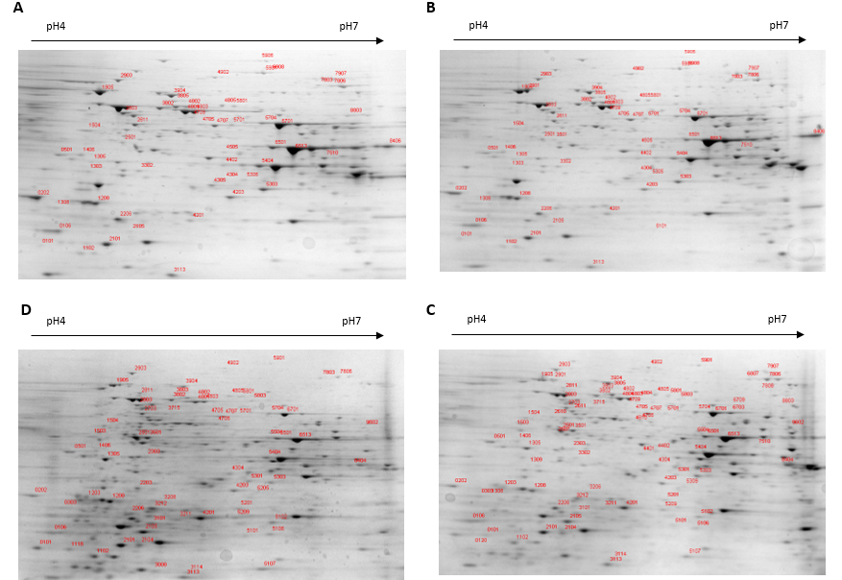
Figure S3. 2D-gel electrophoresis for the 9 h treatments. Yeast proteins (250 μg loaded) were separated over pH range 4-7 (11 cm strips) and 12% SDS-polyacrylamide gel. The gel was stained with Comassie Brilliant Blue. Red numbers in the gels indicate proteins showing quantitative differences, which were further identified by MS approach. A) Control; B) nystatin; C) CdS QDs; D) Nystatin + CdS QDs.

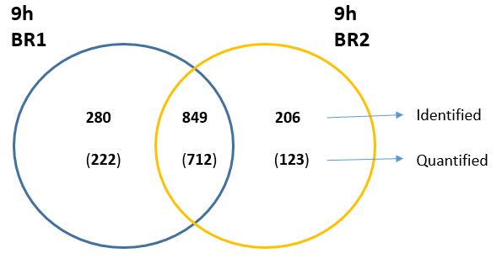
Figure S4. Venn diagram showing the number of unique proteins identified and quantified from the iTRAQ analysis of two biological replicates (BR1 and BR2) for the 9 h treatment corresponding to the four developmental stages.

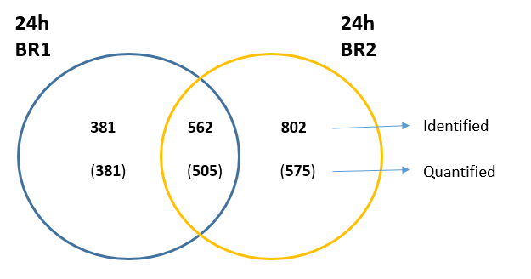
Figure S5. Venn diagram showing the number of unique proteins identified and quantified from the iTRAQ analysis of two biological replicates (BR1 and BR2) for the 24 h treatment corresponding to the four developmental stages.

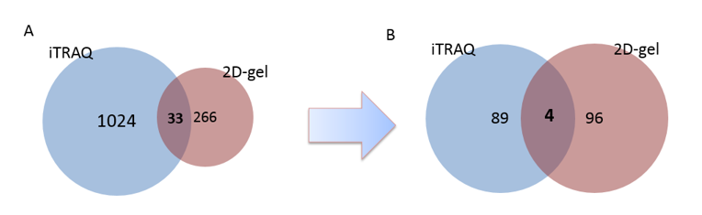
Figure S6. Comparison of the number of proteins isolated and identified with iTRAQ and 2D-PAGE for the 9 h treatment. The Venn diagram (A) depicts the numbers of isolated proteins. The Venn diagram (B) depicts the numbers of significantly modulated proteins.

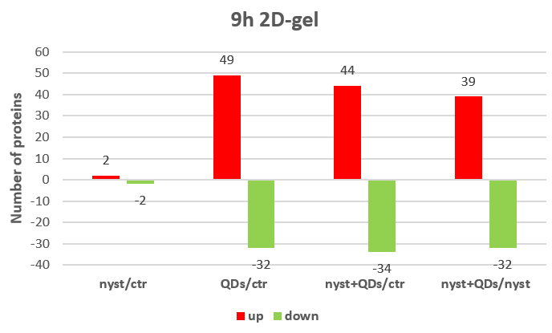
A
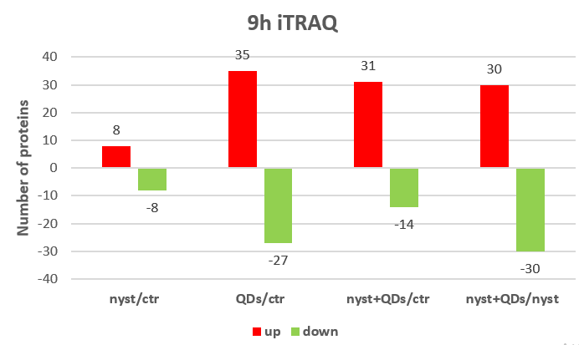
B
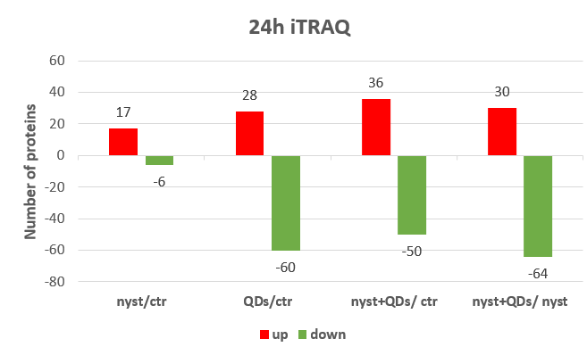
C
Figure S7. Proteins differentially regulated in the four conditions. A) 9 h iTRAQ; B) 9 h 2D-gel electrophoresis; C) 24 h i TRAQ. Red bars: upregulated proteins, green bars: downregulated proteins.
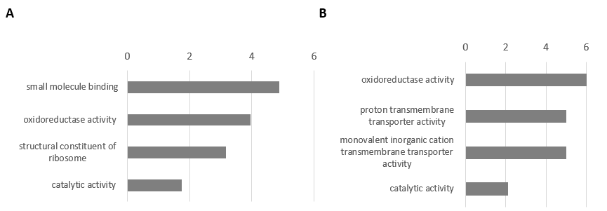
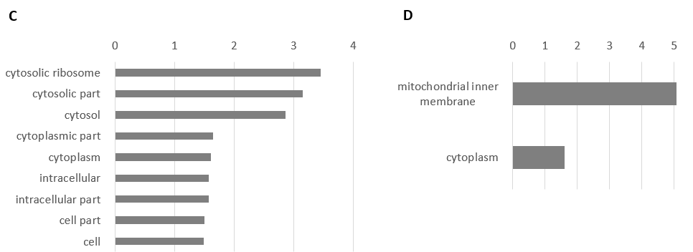

Figure S8. Gene Ontology slim, enrichment analyses with fold enrichment = -log10 (Fisher’s exact p value) for: A) 9h Molecular function; B) 24h treatments Molecular function; C) 9h Cell component; D) 24h Cell component.

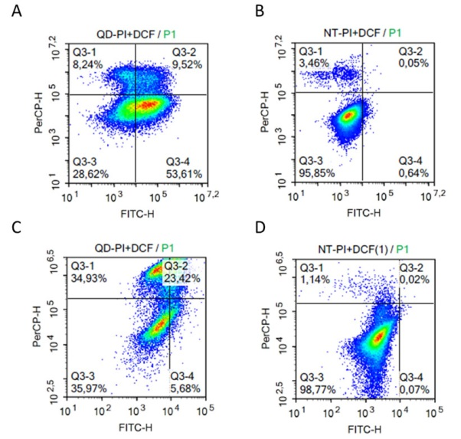
Figure S9. Flow cytometry measurements. Yeast were stained with DCFHDA and PI and detected by flow cytometry after 30 minutes incubation in the dark. The lateral axis represents the fluorescence of DCFH while vertical axis indicates PI intensity of detected cells. A) Control for 9h; B) treatment for 9h; C9 control for 24 h; D) Treatment for 24 h.

Table S4: Description of the differentially expressed proteins at 9h with 2d-gel (a), 9h with iTRAQ (b), and 24h with iTRAQ (c).
 | Proteins | Gene | pathway code | pathway name | description
c | (DL)-glycerol-3-phphatase 2 | HOR2 | sce00561  sce01100 | Glycerolipid metabolism  Metabolic pathways | Major isoform of glycerol-1-phosphate phosphohydrolase involved in glycerol biosynthesis. Plays a role in osmoadaptation and required for adaptation to anaerobic conditions.
a | 1-(5-phosphoribosyl)-5-[(5-phosphoribosylamino)methylideneamino] imidazole-4-carboxamide isomerase | HIS6 | sce00340 sce01100 sce01110 sce01230 | Histidine metabolism  metabolic pathway  Biosynthesis of secondary metabolites Biosynthesis of amino acids. | Catalyzes the isomerization of the aminoaldose moiety of ProFAR to the aminoketose of PRFAR.
c | 1,3-beta-glucan synthase component FKS1 | FKS1 | sce00500  sce01100  sce04011 | Starch and sucrose metabolism  Metabolic pathways  MAPK signaling pathway | Alternate catalytic subunit of the 1,3-beta-glucan synthase (GS). Synthesizes 1,3-beta-glucan, a major structural component of the yeast cell wall. Involved in cell wall synthesis, maintenance and cell wall remodeling.
b | 1,3-beta-glucan synthase component GSC2 | GSC2 | sce00500,  sce04011 | Starch and sucrose metabolism,  Map kinase | Alternate catalytic subunit of the 1,3-beta-glucan synthase (GS). Synthesizes 1,3-beta-glucan, a major structural component of the yeast cell wall. Required for spore wall assembly. Negative regulation of activity by SMK1 is important for spore wall deposition. Activity is positively regulated by RHO1.
b | 1,3-beta-glucanosyltransferase GAS1 | GAS1 |  |  | Involved in cell wall biosynthesis and morphogenesis.
c | 1,4-alpha-glucan-branching enzyme | GLC3 | sce00500  sce01100  sce01110 | Starch and sucrose metabolism  Metabolic pathways  Biosynthesis of secondary metabolites | is involved in the pathway glycogen biosynthesis, which is part of Glycan biosynthesis.
c | 12 kDa heat shock protein | HSP12 |  |  | May play a role in a switch from carbohydrate utilizing metabolism to fatty acid utilizing metabolism.
a | 25S rRNA (uridine(2843)-N(3))-methyltransferase | BMT6 |  |  | S-adenosyl-L-methionine-dependent methyltransferase that specifically methylates the N₃ position of uridine in 25S rRNA.
c | 2-oxoglutarate dehydrogenase, mitochondrial | KGD1 | sce00020  sce01100  sce01110  sce01130  sce01200 | Citrate cycle (TCA cycle)  Metabolic pathways  Biosynthesis of secondary metabolites  Biosynthesis of antibiotics  Carbon metabolism | The 2-oxoglutarate dehydrogenase complex catalyzes the overall conversion of 2-oxoglutarate to succinyl-CoA and CO2.
c | 37S ribomal protein YMR-31, mitochondrial | YMR31
a | 37S ribosomal protein S18, mitochondrial | MRPS18 | sce03010 | Ribosome | Component of the mitochondrial ribosome (mitoribosome), a dedicated translation machinery responsible for the synthesis of mitochondrial genome-encoded proteins, including at least some of the essential transmembrane subunits of the mitochondrial respiratory chain.
a | 37S ribosomal protein S23, mitochondrial | RSM23 | sce03011  sce03029 | Ribosome  Mitochondrial biogenesis | Component of the mitochondrial ribosome (mitoribosome), a dedicated translation machinery responsible for the synthesis of mitochondrial genome-encoded proteins, including at least some of the essential transmembrane subunits of the mitochondrial respiratory chain.
b c | 3-isopropylmalate dehydratase | LEU1 | sce00290  sce01100  sce01110  sce01210  sce01230 | Citrate cycle (TCA cycle)  Metabolic pathways  Biosynthesis of secondary metabolites  2-Oxocarboxylic acid metabolism  Biosynthesis of amino acids | Catalyzes the isomerization between 2-isopropylmalate and 3-isopropylmalate
b | 3-keto-steroid reductase | ERG27 | sce00100  sce01100  sce01130 | Steroid biosynthesis  Metabolic pathway  Biosynthesis of antibiotics | Responsible for the reduction of the keto group on the C-3 of sterols. Also facilitates the association of ERG7 with lipid particles preventing its digestion in the endoplasmic reticulum and the lipid particles.
a | 40S ribosomal protein S0-B | RPS0B | sce03010 | Ribosome | Required for the assembly and/or stability of the 40S ribosomal subunit. Required for the processing of the 20S rRNA-precursor to mature 18S rRNA.
b | 40S ribosomal protein S12 | RPS12 | sce03010 | Ribosome | Component of the ribosome, a large ribonucleoprotein complex responsible for the synthesis of proteins in the cell.
a | 40S ribosomal protein S1-B | RPS1B | sce03010 | Ribosome | Structural constituent of ribosome, translation.
b | 40S ribosomal protein S21-A | RPS21A | sce03010 | Ribosome | Component of the ribosome, a large ribonucleoprotein complex responsible for the synthesis of proteins in the cell.
b | 40S ribosomal protein S21-B | RPS21B | sce03010 | Ribosome | Component of the ribosome, a large ribonucleoprotein complex responsible for the synthesis of proteins in the cell.
b | 40S ribosomal protein S28-B | RPS28B | sce03010 | Ribosome | Component of the ribosome, a large ribonucleoprotein complex responsible for the synthesis of proteins in the cell.
c | 4-aminobutyrate aminotransferase | UGA1 | sce00250  sce00280  sce00410  sce00640  sce00650  sce01100 | Alanine, aspartate and glutamate metabolism  Valine, leucine and isoleucine degradation  beta-Alanine metabolism  Propanoate metabolism  Butanoate metabolism  Metabolic pathways | Required for the degradation of gamma-aminobutyric acid (GABA), which is important for utilization of GABA as nitrogen source and for oxidative stress tolerance.
c | 5-aminolevulinate synthase, mitochondrial | HEM1 |  |  | Catalyzes the synthesis of 5-aminolevulinate (ALA) from succinyl-CoA and glycine.
b | 6,7-dimethyl-8-ribityllumazine synthase | RIB4 | sce00740  sce01100  sce01110 | Metabolism secondary  Metabolic pathway  Biosynthesis of secondary metabolites | Catalyzes the formation of 6,7-dimethyl-8-ribityllumazine by condensation of 5-amino-6-(D-ribitylamino) uracil with 3,4-dihydroxy-2-butanone 4-phosphate.
a | 60S acidic ribosomal protein P0 | RPP0 | sce03010 | Ribosome | Component of the ribosome, a large ribonucleoprotein complex responsible for the synthesis of proteins in the cell.
b | 60S acidic ribosomal protein P1-alpha | RPP1A | sce03010 | Ribosome | Component of the ribosome, a large ribonucleoprotein complex responsible for the synthesis of proteins in the cell.
b | 60S acidic ribosomal protein P1-beta | RPP1B | sce03013 | RNA transport | Component of the ribosome, a large ribonucleoprotein complex responsible for the synthesis of proteins in the cell.
b | 60S ribosomal protein L15-A | RPPL15A | sce03013 | RNA transport | Component of the ribosome, a large ribonucleoprotein complex responsible for the synthesis of proteins in the cell.
a | 60S ribosomal protein L20-A | RPPL20A | sce03010 | Ribosome | Component of the ribosome, a large ribonucleoprotein complex responsible for the synthesis of proteins in the cell.
a | 60S ribosomal protein L20-B | RPPL20B | sce03010 | Ribosome | Component of the ribosome, a large ribonucleoprotein complex responsible for the synthesis of proteins in the cell.
b | 60S ribosomal protein L22-A | RPPL22A | sce03013 | RNA transport | Component of the ribosome, a large ribonucleoprotein complex responsible for the synthesis of proteins in the cell.
b | 60S ribosomal protein L31-A | RPPL31A | sce03013 | RNA transport | Component of the ribosome, a large ribonucleoprotein complex responsible for the synthesis of proteins in the cell.
b | 60S ribosomal protein L43-A | RPPL43A | sce03013 | RNA transport | Component of the ribosome, a large ribonucleoprotein complex responsible for the synthesis of proteins in the cell.
bc | 78 kDa gluce-regulated protein homolog | KAR2 | sce03060  sce04141 | Protein export  Protein processing in endoplasmic reticulum | Probably plays a role in facilitating the assembly of multimeric protein complexes inside the ER. Is required for secretory polypeptide translocation. May physically associate with SEC63 protein in the endoplasmic reticulum and this interaction may be regulated by ATP hydrolysis.
c | Accumulation of dyads protein 2 | ADY2 |  |  | Transporter protein required for ammonia export and acetate uptake and resistance. Necessary for up-regulation and down-regulation of meiotic plaque (MP) component levels. Has a role in ascus formation.
c | Acetyl-CoA hydrolase | ACH1 | sce00620  sce01100 | Pyruvate metabolism  Metabolic pathways | Presumably involved in regulating the intracellular acetyl-CoA pool for fatty acid and cholesterol synthesis and fatty acid oxidation.
c | Acetyl-coenzyme A synthetase 1 | ACS1 | sce00010  sce00620  sce00630  sce00640  sce00680  sce01100  sce01110  sce01110  sce01130  sce01200 | Glycolysis / Gluconeogenesis  Pyruvate metabolism  Glyoxylate and dicarboxylate metabolism  Propanoate metabolism  Methane metabolism  Metabolic pathways  Biosynthesis of secondary metabolites  Biosynthesis of antibiotics  Carbon metabolism | Catalyzes the production of acetyl-CoA. Provides the acetyl-CoA source for histone acetylation in the nucleus. "Aerobic" isozyme of acetyl-coenzyme A synthetase, which supports growth on nonfermentable carbon sources such as glycerol and ethanol.
c | Aconitate hydratase, mitochondrial | ACO1 | sce00020  sce00630  sce01100  sce01110  sce01130  sce01200  sce01210  sce01230 | Citrate cycle (TCA cycle)  Glyoxylate and dicarboxylate metabolism  Metabolic pathways  Biosynthesis of secondary metabolites  Biosynthesis of antibiotics  Carbon metabolism  2-Oxocarboxylic acid metabolism  Biosynthesis of amino acids | Catalyzes the isomerization of citrate to isocitrate via cis-aconitate, a step in the citric acid cycle. Plays also an essential role in mtDNA maintenance.
a | Acyl-CoA-binding protein | ACH1 |  |  | Binds medium- and long-chain acyl-CoA esters with very high affinity and may function as an intracellular carrier of acyl-CoA esters.
b | Adenylosuccinate synthetase | ADE12 | sce00230  sce00250 sce01100  sce01130 | Purine metabolism  Alanine, aspartate and glutamate metabolism  Metabolism secondary  Biosynthesis of secondary metabolites Biosynthesis of antibiotics | Plays an important role in the de novo pathway and in the salvage pathway of purine nucleotide biosynthesis. Catalyzes the first committed step in the biosynthesis of AMP from IMP.
bc | Adenyluccinate lyase | ADE13 | sce00230  sce00230  sce00230  sce00230  sce00230 | Purine metabolism  Alanine, aspartate and glutamate metabolism  Metabolic pathways  Biosynthesis of secondary metabolites  Biosynthesis of antibiotics | This protein is involved in step of the subpathway that synthesizes AMP from IMP.
c | Alcohol dehydrogenase 2 | ADH2 | sce00010  sce00010  sce00010  sce00010  sce00010  sce00010 | Glycolysis / Gluconeogenesis  Fatty acid degradation  Tyrosine metabolism  Metabolic pathways  Biosynthesis of secondary metabolites  Biosynthesis of antibiotics | This isozyme preferentially catalyzes the conversion of ethanol to acetaldehyde. Acts on a variety of primary unbranched aliphatic alcohols.
b | Alpha,alpha-trehalose-phosphate synthase [UDP-forming] 56 kDa subunit | TPS1 | sce00500 sce01100 | Starch and sucrose metabolism  Biosynthesis of secondary metabolites | Synthase catalytic subunit of the trehalose synthase complex that catalyzes the production of trehalose from glucose-6-phosphate and UDP-glucose in a two steps process.
c | Altered inheritance of mitochondria protein 46, mitochondrial | AIM46
b | Arginase | CAR1 | sce00220 sce00330 sce01100  sce01110 sce01130 | Arginine biosynthesis  Arginine and proline biosynthesis  Metabolic pathway  Secondary metabolites  Biosynthesis of antibiotics | This protein is involved in the subpathway that synthesizes L-ornithine and urea from L-arginine.
c | Asparagine synthetase [glutamine-hydrolyzing] 2 | ASN2 | sce00250  sce01100  sce01110  sce01230 | Alanine, aspartate and glutamate metabolism  Metabolic pathways  Biosynthesis of secondary metabolites  Biosynthesis of amino acids | This protein is involved in step of the subpathway that synthesizes L-asparagine from L-aspartate (L-Gln route).
a | Asparagine--tRNA ligase, cytoplasmic | DED81 | sce00970 | Aminoacyl-tRNA biosynthesis | Asparagine-tRNA ligase activity and ATP binding
b | Aspartic proteinase MKC7 | MKC7 | sce04011 | mapk kinase | Cleaves proteins C-terminally to the most C-terminal basic residue.
c | ATP synthase subunit 5, mitochondrial | ATP5 | sce00190  sce01100 | Oxidative phosphorylation  Metabolic pathways | Mitochondrial membrane ATP synthase (F₁F₀ ATP synthase or Complex V) produces ATP from ADP in the presence of a proton gradient across the membrane which is generated by electron transport complexes of the respiratory chain.
c | ATP synthase subunit d, mitochondrial | ATP7 | sce00190  sce01100 | Oxidative phosphorylation  Metabolic pathways | Mitochondrial membrane ATP synthase (F₁F₀ ATP synthase or Complex V) produces ATP from ADP in the presence of a proton gradient across the membrane which is generated by electron transport complexes of the respiratory chain
c | ATP synthase subunit delta, mitochondrial | ATP16 | sce00190  sce01100 | Oxidative phosphorylation  Metabolic pathways | Mitochondrial membrane ATP synthase (F1F0 ATP synthase or Complex V) produces ATP from ADP in the presence of a proton gradient across the membrane which is generated by electron transport complexes of the respiratory chain
c | ATP synthase subunit gamma, mitochondrial | ATP3 | sce00190  sce01100 | Oxidative phosphorylation  Metabolic pathways | Mitochondrial membrane ATP synthase (F1F0 ATP synthase or Complex V) produces ATP from ADP in the presence of a proton gradient across the membrane which is generated by electron transport complexes of the respiratory chain
a | ATPase expression protein 2, mitochondrial | AEP2 | sce03029 | Mitochondrial biogenesis | Required for translation of the mitochondrial OLI1 transcript coding for the mitochondrial ATP synthase subunit 9.
a | ATPase synthesis protein 25, mitochondrial | ATP25 |  |  | mRNA stabilization factor specific for the OLI1 mRNA. Also involved in OLI1 ring formation.
a | ATP-dependent 6-phosphofructokinase subunit beta | PFK2 | sce00010  sce00030 sce00051 sce00680 sce01100 sce01110  sce01130 sce01200  sce01230 sce03018 | Glycolysis  Pentose phosphate pathway  Fructose and mannose metabolism  Methane metabolism  Metabolic pathway  Biosynthesis of secondary metabolites Biosynthesis of antibiotics  Carbon metabolism  Biosynthesis of amino acid  RNA degradation | Catalyzes the phosphorylation of D-fructose 6-phosphate to fructose 1,6-bisphosphate by ATP, the first committing step of glycolysis.
ab c | ATP-dependent molecular chaperone HSP82 | HSC82 | sce04141 | Protein processing in endoplasmic reticulum | Molecular chaperone that promotes the maturation, structural maintenance and proper regulation of specific target proteins involved in cell cycle control and signal transduction such as CNA2. Undergoes a functional cycle that is linked to its ATPase activity
b | ATP-dependent RNA helicase DBP3 | DBP3 |  |  | ATP-dependent RNA helicase required for 60S ribosomal subunit synthesis.
b | ATP-dependent RNA helicase DBP5 | DBP5 |  |  | ATP-dependent RNA helicase associated with the nuclear pore complex and essential for mRNA export from the nucleus.
b | ATP-dependent RNA helicase DHH1 | DHH1 | sce03018 | RNA degradation | ATP-dependent RNA helicase involved in mRNA turnover, and more specifically in mRNA decapping by activating the decapping enzyme DCP1.
b c | Bifunctional purine biynthesis protein ADE17 | ADE17 | sce00230  sce00670  sce01100  sce01110  sce01130 | Purine metabolism  One carbon pool by folate  Metabolic pathways  Biosynthesis of secondary metabolites  Biosynthesis of antibiotics | This protein is involved in step 1 of the subpathway that synthesizes 5-formamido-1-(5-phospho-D-ribosyl)imidazole-4-carboxamide from 5-amino-1-(5-phospho-D-ribosyl)imidazole-4-carboxamide.
c | Bifunctional purine biynthetic protein ADE5,7 | ADE5,7 | sce00230  sce01100  sce01110  sce01130 | Purine metabolism  Metabolic pathways  Biosynthesis of secondary metabolites  Biosynthesis of antibiotics | This protein is involved in step 2 of the subpathway that synthesizes 5-amino-1-(5-phospho-D-ribosyl)imidazole from N(2)-formyl-N(1)-(5-phospho-D-ribosyl)glycinamide.
c | Branched-chain-amino-acid aminotransferase, cytosolic | BAT2 | sce00270  sce00280  sce00290  sce00770  sce01100  sce01110  sce01130  sce01210  sce01230 | Cysteine and methionine metabolism  Valine, leucine and isoleucine degradation  Valine, leucine and isoleucine biosynthesis  Pantothenate and CoA biosynthesis  Metabolic pathways  Biosynthesis of secondary metabolites  Biosynthesis of antibiotics  2-Oxocarboxylic acid metabolism  Biosynthesis of amino acids | Catalyzes the first reaction in the catabolism of the essential branched chain amino acids leucine, isoleucine, and valine. Catalyzes the formation of methionine from 2-keto-4-methylthiobutyrate (KMTB) in the methionine salvage pathway primarily using branched chain amino acids (leucine, isoleucine, and valine) as well as lysine and proline as the amino donors. Involved in cell cycle regulation.
b | Branched-chain-amino-acid aminotransferase, mitochondrial | BAT1 | sce00270 sce00280  sce00290 sce00770 sce01100  sce01110 sce01130 sce01210 sce01230 | Cysteine and methionine metabolism  Valine, leucine isoleucine degradation  Valine, leucine isoleucine biosynthesis Pantothenate and CoA biosynthesis  Metabolic pathway  Biosynthesis of secondary metabolites  Biosynthesis of antibiotics  2-Oxocarboxylic acid metabolism  Biosynthesis of amino acids | Involved in the biosynthesis of the branched chain amino acids leucine, isoleucine, and valine.
c | Calcium/calmodulin-dependent protein kinase II | CMK2 |  |  | Important in cellular regulation.
b | Cap-associated protein CAF20 | CAF20 |  |  | Acts as an inhibitor of cap-dependent translation.
c | Carboxylic acid transporter protein homolog | JEN1 |  |  | Essential to lactate transport.
c | Carboxypeptidase Y | PRC1 |  |  | Involved in degradation of small peptides.
a | Cargo-transport protein YPP1 | YPP1 | sce04131 | Endocytosis | Involved in endocytosis.
ac | Carnitine O-acetyltransferase, mitochondrial | CAT2 | sce04146 | Peroxisome | Carnitine acetylase is specific for short chain fatty acids. It may be involved as well in the transport of acetyl-CoA into mitochondria.
a | Cell division control protein 48 | CDC48 | sce04141 | Protein processing in endoplasmic reticulum | Involved in spindle disassembly, degradation of ubiquitinated proteins and protein export from the endoplasmic reticulum to the cytoplasm.
c | Cell division control protein 53 | CDC53 | sce04111  sce04120  sce04141 | Cell cycle - yeast  Ubiquitin mediated proteolysis  Protein processing in endoplasmic reticulum | Core component of multiple cullin-RING-based SCF (SKP1-CUL1-F-box) E3 ubiquitin-protein ligase complexes which mediate the ubiquitination and subsequent proteasomal degradation of target proteins.
b | Cell wall protein ECM33 | ECM33 |  |  | Required for proper cell wall integrity and for the correct assembly of the mannoprotein outer layer of the cell wall. Important for apical bud growth.
b | Cerevisin | PRB1 | sce04138 | Autophagy | Vacuolar proteinase B involved in protein degradation in the vacuole. Required for meiosis and spore formation, and for optimal survival in stationary phase.
c | Chromatin structure-remodeling complex protein RSC8 | RSC8 |  |  | Component of the chromatin structure-remodeling complex (RSC), which is involved in transcription regulation and nucleosome positioning.
c | Citrate synthase, mitochondrial | CIT1 | sce00020  sce00630  sce01100  sce01110  sce01130  sce01200  sce01210  sce01230 | Citrate cycle (TCA cycle)  Glyoxylate and dicarboxylate metabolism  Metabolic pathways  Biosynthesis of secondary metabolites  Biosynthesis of antibiotics  Carbon metabolism  2-Oxocarboxylic acid metabolism  Biosynthesis of amino acids | Specific citrate synthase with catalytic activity only with acetyl-CoA.
c | Citrate synthase, peroxisomal | CIT2 | sce00020  sce00630  sce01100  sce01110  sce01130  sce01200  sce01210  sce01230 | Citrate cycle (TCA cycle)  Glyoxylate and dicarboxylate metabolism  Metabolic pathways  Biosynthesis of secondary metabolites  Biosynthesis of antibiotics  Carbon metabolism  2-Oxocarboxylic acid metabolism  Biosynthesis of amino acids | This protein is involved in step of the subpathway that synthesizes isocitrate from oxaloacetate.
c | Conserved protein | SCY_4038
a | Cystathionine beta-synthase | CYS4 | sce00260 sce00270 sce01100  sce01130 sce01230 | Glycine, sereine and threonine metabolism Cysteine and methionine metabolism  Metabolic pathways  Biosynthesis of antibiotics  Biosynthesis of amino acids | This protein is involved in the subpathway that synthesizes L-cysteine from L-homocysteine and L-serine.
bc | Cystathionine gamma-lyase | CYS3 | sce00260  sce00270  sce00450  sce00110  sce01130  sce01230 | Glycine, serine and threonine metabolism  Cysteine and methionine metabolism  Selenocompound metabolism  Metabolic pathways  Biosynthesis of antibiotics  Biosynthesis of amino acids | This protein is involved in step 2 of the subpathway that synthesizes L-cysteine from L-homocysteine and L-serine.
b | Cysteine proteinase 1, mitochondrial | LAP3 |  |  | The normal physiological role of the enzyme is unknown, but it is not essential for the viability of yeast cells.
a | Cysteine--tRNA ligase | YNL247W | sce00970 | Aminoacyl-tRNA biosynthesis | ATP binding and cysteine-tRNA ligase activity
c | Cytochrome b2, mitochondrial | CYB2 | sce00620  sce01100 | Pyruvate metabolism  Metabolic pathways
c | Cytochrome b-c1 complex subunit 6 | QCR6 | sce00190  sce00110 | Oxidative phosphorylation  Metabolic pathways | Component of the ubiquinol-cytochrome c reductase complex, which is part of the mitochondrial respiratory chain that generates an electrochemical potential coupled to ATP synthesis.
c | Cytochrome b-c1 complex subunit 7 | QCR7 | sce00190  sce00110 | Oxidative phosphorylation  Metabolic pathways | Component of the ubiquinol-cytochrome c reductase complex, which is part of the mitochondrial respiratory chain that generates an electrochemical potential coupled to ATP synthesis. The complex couples electron transfer from ubiquinol to cytochrome c. QCR7 is involved in redox-linked proton pumping.
c | Cytochrome b-c1 complex subunit Rieske, mitochondrial | RIP1 | sce00190  sce00110 | Oxidative phosphorylation  Metabolic pathways | Component of the ubiquinol-cytochrome c reductase complex, which is a respiratory chain that generates an electrochemical potential coupled to ATP synthesis. The complex couples electron transfer from ubiquinol to cytochrome c.
a | Cytochrome c oxidase assembly factor 1 | COA1 |  |  | Required for efficient assembly of cytochrome c oxidase in the mitochondrial inner membrane.
a | Cytochrome c oxidase polypeptide 5A, mitochondrial | COXA | sce00190 sce01100 | Oxidative phosphorylation,  Metabolic pathways | cytochrome-c oxidase activity
c | Cytochrome c oxidase subunit 2 | COX2 | sce00190  sce00110 | Oxidative phosphorylation  Metabolic pathways | Cytochrome c oxidase is the component of the respiratory chain that catalyzes the reduction of oxygen to water. Subunits 1-3 form the functional core of the enzyme complex. Subunit 2 transfers the electrons from cytochrome c via its binuclear copper A center to the bimetallic center of the catalytic subunit 1.
c | Cytochrome c oxidase subunit 4, mitochondrial | COX4 | sce00190  sce00110 | Oxidative phosphorylation  Metabolic pathways | Cytochrome c oxidase is the component of the respiratory chain that catalyzes the reduction of oxygen to water.
c | Cytochrome c oxidase subunit 6, mitochondrial | COX6 | sce00190  sce00110 | Oxidative phosphorylation  Metabolic pathways | This is the heme A-containing chain of cytochrome c oxidase, the terminal oxidase in mitochondrial electron transport.
b | Delta(24(24(1)))-sterol reductase | ERG4 | sce00100 sce01100 sce01130 | Steroid biosynthesis  Metabolic pathway  Biosynthesis of antibiotics | This protein is involved in the subpathway that synthesizes ergosterol from zymosterol.
c | Dihydrolipoyl dehydrogenase | LPD1 | sce00010  sce00020  sce00260  sce00280  sce00310  sce00380  sce00620  sce00630  sce00640  sce01100  sce01110  sce01130  sce01200 | Glycolysis / Gluconeogenesis  Citrate cycle (TCA cycle)  Glycine, serine and threonine metabolism  Valine, leucine and isoleucine degradation  Lysine degradation  Tryptophan metabolism  Pyruvate metabolism  Glyoxylate and dicarboxylate metabolism  Propanoate metabolism  Metabolic pathways  Biosynthesis of secondary metabolites  Biosynthesis of antibiotics  Carbon metabolism | Lipoamide dehydrogenase is a component of the alpha-ketoacid dehydrogenase complexes. This includes the pyruvate dehydrogenase complex, which catalyzes the overall conversion of pyruvate to acetyl-CoA and CO2. Acts also as component of the glycine cleavage system (glycine decarboxylase complex), which catalyzes the degradation of glycine.
c | Dihydrolipoyl dehydrogenase, mitochondrial | LPD1 | sce00010  sce00020  sce00260  sce00280  sce00310  sce00380  sce00620  sce00630  sce00640  sce01100  sce01110  sce01130  sce01200 | Glycolysis / Gluconeogenesis  Citrate cycle (TCA cycle)  Glycine, serine and threonine metabolism  Valine, leucine and isoleucine degradation  Lysine degradation  Tryptophan metabolism  Pyruvate metabolism  Glyoxylate and dicarboxylate metabolism  Propanoate metabolism  Metabolic pathways  Biosynthesis of secondary metabolites  Biosynthesis of antibiotics  Carbon metabolism | Lipoamide dehydrogenase is a component of the alpha-ketoacid dehydrogenase complexes. This includes the pyruvate dehydrogenase complex, which catalyzes the overall conversion of pyruvate to acetyl-CoA and CO2. Acts also as component of the glycine cleavage system (glycine decarboxylase complex), which catalyzes the degradation of glycine.
c | Dihydrolipoyllysine-residue succinyltransferase component of 2-oxoglutarate dehydrogenase complex, mitochondrial | KGD2 | sce00020  sce00310  sce00380  sce00110  sce01110  sce01130  sce01200 | Citrate cycle (TCA cycle)  Lysine degradation  Tryptophan metabolism  Metabolic pathways  Biosynthesis of secondary metabolites  Biosynthesis of antibiotics  Carbon metabolism | The 2-oxoglutarate dehydrogenase complex catalyzes the overall conversion of 2-oxoglutarate to succinyl-CoA and CO2.
c | Dihydroorotate dehydrogenase (fumarate) | URA1 | sce00240  sce01110 | Pyrimidine metabolism  Metabolic pathways | Catalyzes the conversion of dihydroorotate to orotate with fumarate as the electron acceptor.
a | Diphthine methyltransferase | RRT2 |  |  | Catalyzes the demethylation of diphthine methyl ester to form diphthine, a post-translational modification of histidine which occurs in translation elongation factor 2 (EFT1 and EFT2).
b | D-lactate dehydrogenase [cytochrome] 3 | DLD2 | sce00620 | Pyruvate metabolism | Catalyzes the reversible oxidation of (R)-2-hydroxyglutarate to 2-oxoglutarate coupled to reduction of pyruvate to (R)-lactate. Can also use oxaloacetate as electron acceptor instead of pyruvate producing (R)-malate.
a | DNA topoisomerase 3 | TOP3 | sce03440 | Homologous recombination | Releases the supercoiling and torsional tension of DNA introduced during the DNA replication and transcription by transiently cleaving and rejoining one strand of the DNA duplex.
a | Double-strand break repair protein MRE11 | MRE11 | sce03440 sce03450 | Homolugus recombination | Involved in DNA double-strand break repair (DSBR). Possesses single-strand endonuclease activity and double-strand-specific 3'-5' exonuclease activity.
a | Dual-specificity protein phosphatase SDP1 | SDP1 |  |  | Mediates dephosphorylation of MAPK substrates such as SLT2, acquiring enhanced catalytic activity under oxidative conditions.
a | Elongation factor 1-alpha | TEF1 | sce03013 | RNA transport | GTP-binding component of the eukaryotic elongation factor 1 complex (eEF1). In its active GTP-bound form, binds to and delivers aminoacyl-tRNA to the A-site of ribosomes during protein biosynthesis.
bc | Elongation factor 1-beta | EFB1 |  |  | Catalytic subunit of the guanine nucleotide exchange factor (GEF) (eEF1B subcomplex) of the eukaryotic elongation factor 1 complex (eEF1). Stimulates the exchange of GDP for GTP on elongation factor 1A (eEF1A).
a | Elongation factor 2 | EFT1 |  |  | Catalyzes the GTP-dependent ribosomal translocation step during translation elongation.
ac | Enolase 1 | ENO1 | sce00010  sce00680  sce00110  sce01110  sce01130  sce01200  sce01230  sce03018 | Glycolysis / Gluconeogenesis  Methane metabolism  Metabolic pathways  Biosynthesis of secondary metabolites  Biosynthesis of antibiotics  Carbon metabolism  Biosynthesis of amino acids  RNA degradation | This protein is involved in the subpathway that synthesizes pyruvate from D-glyceraldehyde 3-phosphate.
a | Enolase 2 | ENO2 | sce00010 sce00680 sce01100  sce01110 sce01130 sce01200  sce01230 sce03018 | Glycolysis / Gluconeogenesis  Methane metabolism  Metabolic pathways  Biosynthesis of secondary metabolites  Biosynthesis of antibiotics  Carbon metabolism  Biosynthesis of amino acids  RNA degradation | This protein is involved in the subpathway that synthesizes pyruvate from D-glyceraldehyde 3-phosphate.
a | Eukaryotic translation initiation factor 3 subunit A | RPG1 | sce03013 | RNA transport | RNA-binding component of the eukaryotic translation initiation factor 3 (eIF-3) complex, which is involved in protein synthesis of a specialized repertoire of mRNAs and, together with other initiation factors, stimulates binding of mRNA and methionyl-tRNAi to the 40S ribosome.
c | Eukaryotic translation initiation factor 3 subunit J | HCR1 | sce03013 | RNA transport | Is involved in NO detoxification in an aerobic process.
b | Eukaryotic translation initiation factor 5A-1 | HYP2 |  |  | mRNA-binding protein involved in translation elongation.
bc | FACT complex subunit POB3 | POB3 |  |  | Component of the FACT complex, a general chromatin factor that acts to reorganize nucleosomes.
a | Factor arrest protein 3 | FAR3 |  |  | Participates in the control of the reentry into the cell cycle following pheromone treatment.
abc | Fructose-bisphosphate aldolase | FBA1 | sce00010  sce00030  sce00051  sce00680 sce01100 sce01110  sce01130 sce01200 sce01230 | Glycolysis  Pentose phosphate pathway,  Fructose and mannose metabolism  Methane metabolism  Metabolic pathway  Biosynthesis of secondary metabolites Biosynthesis of antibiotics  Carbon metabolism  Biosynthesis of amino acid | Catalyzes the aldol condensation of dihydroxyacetone phosphate (DHAP or glycerone-phosphate) with glyceraldehyde 3-phosphate (G3P) to form fructose 1,6-bisphosphate (FBP) in gluconeogenesis and the in glycolysis.
c | Flavohemoprotein | YHB1 |  |  | Is involved in NO detoxification in an aerobic process, termed nitric oxide dioxygenase (NOD) reaction. Therefore, plays a central role in the inducible response to nitrosative stress.
a | Folic acid synthesis protein FOL1 | FOL1 | sce00790 sce01100 | folate biosynthesis  Metabolic pathway | Catalyzes three sequential steps of tetrahydrofolate biosynthesis.
c | Fructe-1,6-bisphphatase | FBP1 | sce00010  sce00030  sce00051  sce00680  sce01100  sce01110  sce01130  sce01200 | Glycolysis / Gluconeogenesis  Pentose phosphate pathway  Fructose and mannose metabolism  Methane metabolism  Metabolic pathways  Biosynthesis of secondary metabolites  Biosynthesis of antibiotics  Carbon metabolism | This protein is involved in the pathway gluconeogenesis, which is part of Carbohydrate biosynthesis.
c | Fumarate hydratase, mitochondrial | FUM1 | sce00020  sce00620  sce01100  sce01110  sce01130  sce01200 | Citrate cycle (TCA cycle)  Pyruvate metabolism  Metabolic pathways  Biosynthesis of secondary metabolites  Biosynthesis of antibiotics  Carbon metabolism | Catalyzes the reversible stereospecific interconversion of fumarate to L-malate. In mitochondrion, catalyzes the hydration of fumarate to L-malate in the tricarboxylic acid (TCA) cycle to facilitate a transition step in the production of energy in the form of NADH. In cytoplasm and nucleus, involved in DNA repair in response to DNA damage.
a | Genetic interactor of prohibitins 3, mitochondrial | GEP3 | sce03009 | ribosome biogenesis | Interacts genetically with prohibitins and thus may be involved in the mitochondrial lipid metabolism.
b | Glucokinase-1 | GLK1 | sce00010 sce00051 sce00052  sce00500 sce00520 sce01100  sce01110 sce01130 sce01200 | Glycolysis / Gluconeogenesis  Fructose and mannose metabolism  Galactose metabolism  Starch and sucrose metabolism  Amino sugar and nucleotide sugar metabolism Metabolic pathway  Secondary metabolites  Biosynthesis of antibiotics  Carbon metabolism | Two isoenzymes, hexokinase-1 and hexokinase-2, can phosphorylate keto- and aldohexoses in yeast, whereas a third isoenzyme, GLK, is specific for aldohexoses.
b | Glucosamine--fructose-6-phosphate aminotransferase [isomerizing] | GFA1 | sce00250 sce00520  sce01100  sce01130 | Alanine aspartate gutamate metabolism  Amino sugar and nucleotide sugar metabolism  Metabolic pathway  Biosynthesis of antibiotics | Involved in amino sugar synthesis (formation of chitin, supplies the amino sugars of asparagine-linked oligosaccharides of glycoproteins).
b | Glucose-6-phosphate 1-dehydrogenase | ZWF1 | sce00030  sce04800 sce01100 sce01110 sce01130 sce01200 | Pentose phosphate pathway  Glutatione metabolism  Metabolic pathway  Secondary metabolites  Biosynthesis of antibiotics  Carbon metabolism | Catalyzes the rate-limiting step of the oxidative pentose-phosphate pathway. The main function of this enzyme is to provide reducing power (NADPH) and pentose phosphates for fatty acid and nucleic acid synthesis.
a | Glucose-6-phosphate 1-epimerase | YMR099C |  |  | Catalyzes the interconversion between the alpha and beta anomers from at least three hexose 6-phosphate sugars (Glc6P, Gal6P, and Man6P).
a | Glucose-6-phosphate isomerase | PGI1 | sce00010 sce00030 sce00500  sce00520  sce01100 sce01110 sce01130 sce01200 | Glycolysis / Gluconeogenesis  Pentose phosphate pathway  Fructose and mannose metabolism  Methane metabolism, metabolic pathway Biosynthesis of secondary metabolites Biosynthesis of antibiotics  Carbon metabolism | This protein is involved in the subpathway that synthesizes D-glyceraldehyde 3-phosphate and glycerone phosphate from D-glucose.
bc | Glutamate synthase [NADH] | GLT1 | sce00250  sce00910 sce01100 sce01110 sce01130 sce01230 | Alanine aspartate glutamate metabolism  Nitrogen metabolism  Metabolic pathway  Secondary metabolites  Biosynthesis of antibiotics  Biosynthesis of amino acid | Forms L-glutamate from L-glutamine and 2-oxoglutarate.
bc | Glutamine synthetase | GLN1 | sce00250 sce00220  sce00630 sce00910  sce01100 sce01230 | Alanine aspartate glutamate metabolism arginine Biosynthesis glyoxylate and dicarboxylate Metabolism nitrogen pathway  Metabolic pathway  Biosynthesis of amino acid | ATP binding and glutamate-ammonia ligase activity.
a | Glutaredoxin-1 | GRX1 |  |  | Component of the glutathione system which performs several activities such as glutathione-dependent oxidoreductase, glutathione peroxidase and glutathione S-transferase (GST) activity.
a | Glutathione S-transferase omega-like 1 | GTO1 |  |  | Active as '1-Cys' thiol transferase against beta-hydroxyethyl disulfide (HED), as dehydroascorbate reductase and as dimethylarsinic acid reductase.
a | Glutathione S-transferase omega-like 3 | GTO3 |  |  | Active as '1-Cys' thiol transferase against beta-hydroxyethyl disulfide (HED), as dehydroascorbate reductase and as dimethylarsinic acid reductase.
b | Glyceraldehyde-3-phosphate dehydrogenase 1 | TDH1 | sce00010  sce01100  sce01110  sce01130  sce01200  sce01230 | Glycolysis / Gluconeogenesis  Metabolic pathway  Secondary metabolites  Biosynthesis of antibiotic  Carbon metabolism  Biosynthesis of amino acid | This protein is involved in the subpathway that synthesizes pyruvate from D-glyceraldehyde 3-phosphate.
c | Glyceraldehyde-3-phosphate dehydrogenase 2 | TDH2 | sce00010  sce01100  sce01110  sce01130  sce01200  sce01230 | Glycolysis / Gluconeogenesis  Metabolic pathways  Biosynthesis of secondary metabolites  Biosynthesis of antibiotics  Carbon metabolism  Biosynthesis of amino acids | This protein is involved in step 1 of the subpathway that synthesizes pyruvate from D-glyceraldehyde 3-phosphate.
a | Glyceraldehyde-3-phosphate dehydrogenase 3 | TDH3 | sce00010  sce01100  sce01110  sce01130  sce01200  sce01230 | Glycolysis / Gluconeogenesis  Metabolic pathways  Biosynthesis of secondary metabolites  Biosynthesis of antibiotics  Carbon metabolism  Biosynthesis of amino acids | This protein is involved in the subpathway that synthesizes pyruvate from D-glyceraldehyde 3-phosphate.
b | Glycerol-3-phosphate dehydrogenase [NAD(+)] 1 | GPD1 | sce04011  sce01110 | Mapk kinase  Metabolic pathway | Catalyzes the production and accumulation of glycerol during hyperosmotic stress conditions.
c | Glycerol-3-phosphate dehydrogenase, mitochondrial | GUT2 | sce00564  sce01110 | Glycerophospholipid metabolism  Biosynthesis of secondary metabolites | This protein is involved in step 1 of the subpathway that synthesizes glycerone phosphate from sn-glycerol 3-phosphate (anaerobic route).
a | Glycogen [starch] synthase isoform 2 | GYS2 |  |  | Transfers the glycosyl residue from UDP-Glc to the non-reducing end of alpha-1,4-glucan. Is believed to regulate the synthesis of glycogen.
c | Glycogen phosphorylase | GPH1 | sce00500  sce01100  sce01110 | Starch and sucrose metabolism  Metabolic pathways  Biosynthesis of secondary metabolites | Phosphorylase is an important allosteric enzyme in carbohydrate metabolism.
b | Glycolipid 2-alpha-mannosyltransferase | KRE2 | sce00514 | N-glycan biosynthesis | Mannosyltransferase that transfers an alpha-D-mannosyl residue from GDP-mannose into lipid-linked oligosaccharide, forming an alpha-(1->2)-D-mannosyl-D-mannose linkage. Required for the attachment of the third mannose residue of O-linked saccharides.
a | GTPase-interacting component 2 | GIC2 |  |  | Required for cell size and shape control, bud site selection, bud emergence, actin cytoskeletal organization, mitotic spindle orientation/positioning, and mating projection formation in response to mating pheromone.
a | GTP-binding protein YPT11 | YPT11 |  |  | Involved in the positive control of both endoplasmic reticulum (ER) and mitochondrion inheritance during cell divison.
a | Guanylate kinase | GUK1 | sce00230, sce01100 | Purine metabolism  Metabolic pathways | Essential for recycling GMP and indirectly, cGMP.
bc | Heat shock protein 26 | HSP26 | sce04141 | Protein processing in endoplasmic reticulum | One of the major polypeptides produced on heat shock
b | Heat shock protein 78, mitochondrial | HSP78 |  |  | Required for the dissociation, resolubilization and refolding of aggregates of damaged proteins in the mitochondrial matrix after heat stress.
bc | Heat shock protein SSA1 | SSA1 | sce03040  sce04141  sce04144  sce04213 | Spliceosome  Protein processing in endoplasmic reticulum  Endocytosis  Longevity regulating pathway - multiple species | May play a role in the transport of polypeptides both across the mitochondrial membranes and into the endoplasmic reticulum.
b | Heat shock protein STI1 | STI1 |  |  | May play a role in mediating the heat shock response of some HSP70 genes. It is required for optimal growth of yeast cells at both low and high temperature.
c | Hexokinase-1 | HXK1 | sce00010  sce00051  sce00052  sce00500  sce00520  sce01100  sce01110  sce01130  sce01200 | Glycolysis / Gluconeogenesis  Fructose and mannose metabolism  Galactose metabolism  Starch and sucrose metabolism  Amino sugar and nucleotide sugar metabolism Metabolic pathways  Biosynthesis of secondary metabolites  Biosynthesis of antibiotics  Carbon metabolism | This protein is involved in the pathway hexose metabolism, which is part of Carbohydrate metabolism.
a | Histone acetyltransferase GCN5 | GCN5 |  |  | Acetylates histone H2B
ab | Homocysteine/cysteine synthase | MET17 | sce00270  sce00920  sce01100 sce01110 sce01130 sce01200  sce01230 | Cysteine and methionine metabolism  sulphur metabolism  metabolic pathway,  biosynthesis of secondary metabolites biosynthesis of antibiotics  carbon metabolism  biosynthesis of amino acid | Catalyzes the conversion of O-acetyl-L-homoserine (OAH) into homocysteine in the methionine biosynthesis pathway.
b | Homoisocitrate dehydrogenase, mitochondrial | LYS12 | sce00300  sce01100 sce01130 sce01230 | lysine biosynthesis  secondary metabolites  biosynthesis of antibiotics  biosynthesis of amino acid | Catalyzes the NAD⁺-dependent conversion of homoisocitrate to alpha-ketoadipate.
a | Ingression protein 1 | INN1 |  |  | Required for the ingression of the plasma membrane into the bud neck at the end of cytokinesis, leading to the separation of the mother and daughter cells. Stimulates the synthesis of the primary septum (PS) by CHS2.
b | Inorganic phosphate transporter PHO84 | PHO84 |  |  | High-affinity transporter for external inorganic phosphate.
a | Inorganic phosphate transporter PHO86 | PHO86 |  |  | Involved in the uptake of inorganic phosphate.
c | Iron transport multicopper oxidase FET3 | FET3 |  |  | Iron transport multicopper ferroxidase required for Fe2+ ion high affinity uptake. Required to oxidize Fe2+ and release it from the transporter.
c | Iron transporter SMF3 | SMF3 |  |  | Has a role in controlling the cellular iron ion levels. Mobilizes vacuolar stores of iron in conditions of low iron levels.
a | Iron-sulfur assembly protein 2 | ISA1 |  |  | Involved in the assembly of mitochondrial and cytoplasmic iron-sulfur proteins.
a | Isocitrate dehydrogenase [NAD] subunit 2, mitochondrial | IDH2 | sce00020  sce01100 sce01110 sce01130 sce01200 sce01230 | Citrate cycle (TCA cycle)  Metabolic pathway  Biosynthesis of secondary metabolites  Biosynthesis of antibiotics  Carbon metabolism  Biosynthesis of amino acid | Performs an essential role in the oxidative function of the citric acid cycle. Also binds RNA.
c | Isocitrate dehydrogenase [NADP] cytoplasmic | IDP2 | sce00020  sce00480  sce01100  sce01110  sce01130  sce01200  sce01210  sce01230  sce04146 | Citrate cycle (TCA cycle)  Glutathione metabolism  Metabolic pathways  Biosynthesis of secondary metabolites  Biosynthesis of antibiotics  Carbon metabolism  2-Oxocarboxylic acid metabolism  Biosynthesis of amino acids  Peroxisome | May function in the production of NADPH for fatty acid and sterol synthesis.
c | Isocitrate lyase | ICL1 | sce00630  sce01100  sce01110  sce01200 | Glyoxylate and dicarboxylate metabolism Metabolic pathways  Biosynthesis of secondary metabolites  Carbon metabolism | Catalyzes the formation of succinate and glyoxylate from isocitrate, a key step of the glyoxylate cycle, which operates as an anaplerotic route for replenishing the tricarboxylic acid cycle. Required for growth on ethanol or acetate, but dispensable when fermentable carbon sources are available.
b | Ketol-acid reductoisomerase, mitochondrial | ILV5 | sce00290 sce00770 sce01100 sce01110 sce01130  sce01210  sce01230 | Valine leucine isoleucine biosynthesis, Pantothenate and CoA biosynthesis,  Metabolic pathway,  Biosynthesis of secondary metabolites,  Biosynthesis of antibiotics  2-Oxocarboxylic acid metabolism  Biosynthesis of amino acids | This protein is involved in the subpathway that synthesizes L-isoleucine from 2-oxobutanoate.
a | Kinesin-related protein SMY1 | SMY1 | sce04144 | Endocytosis | Possible microtubule-based motor that can interact or substitute with myosin 2 (MYO2).
a | Kinetochore protein NUF2 | NUF2 |  |  | Acts as component of the essential kinetochore-associated NDC80 complex, which is involved in chromosome segregation and spindle checkpoint activity.
c | Low-affinity gluce transporter HXT3 | HXT3 | sce04113 | Meiosis - yeast | Low-affinity glucose transporter.
c | Malate dehydrogenase, mitochondrial | MDH1 | sce00020  sce00270  sce00620  sce00630  sce01100  sce01110  sce01130  sce01200 | Citrate cycle (TCA cycle)  Cysteine and methionine metabolism  Pyruvate metabolism  Glyoxylate and dicarboxylate metabolism  Metabolic pathways  Biosynthesis of secondary metabolites  Biosynthesis of antibiotics  Carbon metabolism
c | Malate synthase 1, glyoxysomal | MLS1 | sce00620  sce00630  sce00110  sce01110  sce01200 | Pyruvate metabolism  Glyoxylate and dicarboxylate metabolism  Metabolic pathways  Biosynthesis of secondary metabolites  Carbon metabolism | This isozyme is necessary for growth on acetate as sole C-source.
a | Mediator of RNA polymerase II transcription subunit 4 | MED4 |  |  | Component of the Mediator complex, a coactivator involved in the regulated transcription of nearly all RNA polymerase II-dependent genes.
c | Meiotic sister chromatid recombination protein 1 | MSC1
a | Meiotic sister-chromatid recombination protein 6, mitochondrial | MSC6 |  |  | May be involved in the control of meiotic sister-chromatid recombination.
a | Mitochondrial carrier protein MTM1 | MTM1 |  |  | Involved in the mitochondrial activation of SOD2 by specifically facilitating insertion of the essential manganese cofactor.
a | Mitochondrial import inner membrane translocase subunit TIM54 | TIM54 |  |  | Essential component of the TIM22 complex, a complex that mediates the import and insertion of multi-pass transmembrane proteins into the mitochondrial inner membrane.
a | Mitochondrial morphogenesis protein SLD7 | SLS7 |  |  | Required for the proper function of SLD3 at the initiation of DNA replication. Binds to SLD3 and reduces its affinity for CDC45, a component of the replication fork. Required for mitochondrial morphology.
c | Mitochondrial outer membrane protein OM14 | OM14
c | Mitochondrial outer membrane protein OM45 | OM45
c | Mitochondrial outer membrane protein porin 1 | POR1 |  |  | Forms a channel through the cell membrane that allows diffusion of small hydrophilic molecules.
b | Mitochondrial peroxiredoxin PRX1 | PRX1 |  |  | Involved in mitochondrial protection of cadmium-induced oxidative stress.
c | Mitochondrial phosphate carrier protein | MIR1 |  |  | Transport of phosphate groups from the cytosol to the mitochondrial matrix.
a | Multiple RNA-binding domain-containing protein 1 | PRD1 |  |  | Involved in pre-rRNA processing. Required for maintaining steady-state levels of 40S ribosomal subunit.
c | Multiprotein-bridging factor 1 | MBF1 |  |  | Transcriptional coactivator that stimulates GCN4-dependent transcriptional activity by bridging the DNA-binding region of GCN4 and TBP (SPT15), thereby recruiting TBP to GCN4-bound promoters.
c | Myosin-2 | MYO2 |  |  | Myosin heavy chain that is required for the cell cycle-regulated transport of various organelles and proteins for their segregation. Essential for the delivery of secretory vesicles to sites of active growth during bud emergence and cytokinesis. Required for segregation and inheritance of peroxisomes, late Golgi compartments, mitochondria and the vacuole to the daughter cell during cell division. Also required for correct alignment of the spindle during mitosis.
c | NAD(P)H-hydrate epimerase | YNL200C |  |  | Catalyzes the epimerization of the S- and R-forms of NAD(P)HX, a damaged form of NAD(P)H that is a result of enzymatic or heat-dependent hydration.
a | NAD-dependent histone deacetylase SIR2 | SIR2 | sce00760 sce01100  sce04213 | Niconitate and nicotinamide metabolism metabolic pathway  peroxisome | NAD-dependent deacetylase, which participates in a wide range of cellular events including chromosome silencing, chromosome segregation, DNA recombination and the determination of life span.
c | NADH-cytochrome b5 reductase 2 | MCR1 | sce00520 | Amino sugar and nucleotide sugar metabolism | The outer membrane form may mediate the reduction of outer membrane cytochrome b5, and the soluble inter-membrane space form may transfer electrons from external NADH to cytochrome c, thereby mediating an antimycin-insensitive, energy-coupled oxidation of external NADH by yeast mitochondria.
a | NADP-dependent alcohol dehydrogenase 6 | ADH6 | sce00010 sce00040 sce00561 sce01100 sce01110  sce01130 | Glycolysis / Gluconeogenesis  pentose and glucoronate interconversion glycerolipid metabolism  metabolic pathway  biosynthesis of secondary metabolites  biosynthesis of antibiotics | NADP-dependent alcohol dehydrogenase with a broad substrate specificity.
a | NADP-dependent alcohol dehydrogenase 7 | ADH7 | sce00010 sce00040  sce00561 sce01100 sce01110  sce01130 | Glycolysis / Gluconeogenesis  pentose and glucoronate interconversion glycerolipid metabolism  metabolic pathway  biosynthesis of secondary metabolites  biosynthesis of antibiotics | NADP-dependent alcohol dehydrogenase with a broad substrate specificity.
bc | NADPH-dependent alpha-keto amide reductase | YDL124W |  |  | Involved in mitochondrial protection of cadmium-induced oxidative stress.
c | NADPH-dependent methylglyoxal reductase GRE2 | GRE2 | sce00620  sce00640  sce01100  sce04011 | Pyruvate metabolism  Propanoate metabolism  Metabolic pathways  MAPK signaling pathway - yeast | Catalyzes the irreversible reduction of the cytotoxic compound methylglyoxal (MG, 2-oxopropanal) to (S)-lactaldehyde as an alternative to detoxification of MG by glyoxalase I GLO1. Also involved in ergosterol metabolism.
b | NADP-specific glutamate dehydrogenase 1 | GDH1 | sce00220 sce00250 sce00910  sce01100 | arginine biosynthesis  arginine alanine glutamine biosynthesis nitrogen metabolism  metabolic pathway | ammonia assimilation cycle and glutamate biosynthetic process
bc | NAD-specific glutamate dehydrogenase | GDH2 | sce00220  sce00250  sce00430  sce00910  sce01100 | Arginine biosynthesis  Alanine, aspartate and glutamate metabolism  Taurine and hypotaurine metabolism  Nitrogen metabolism  Metabolic pathways | degrades glutamate to ammonia and alpha-ketoglutarate.
c | NAPDH dehydrogenase (Old yellow enzyme), isoform 2 | OYE2 |  |  | Oxidizes beta-NADH, beta-NADPH, and alpha-NADPH.
a | Nicotinamide riboside kinase | NRK1 |  |  | Catalyzes the phosphorylation of nicotinamide riboside (NR) and nicotinic acid riboside (NaR)
b | Nucleoporin NUP120 | NUP120 | sce03013 | RNA transport | Functions as a component of the nuclear pore complex (NPC).
c | Nucleoside diphosphate kinase | YNK1 | sce00230  sce00240  sce01100  sce01110  sce01130 | Purine metabolism  Pyrimidine metabolism  Metabolic pathways  Biosynthesis of secondary metabolites  Biosynthesis of antibiotics | Major role in the synthesis of nucleoside triphosphates other than ATP. The ATP gamma phosphate is transferred to the NDP beta phosphate via a ping-pong mechanism, using a phosphorylated active-site intermediate. Required for repair of UV radiation- and etoposide-induced DNA damage
c | Palmitoyltransferase AKR1 | AKR1 |  |  | Palmitoyltransferase specific for casein kinase 1.
a | Partitioning protein REP1 | REP1 |  |  | Part of the plasmid partitioning system, which ensures the equal distribution of replicated plasmid molecules to daugther cells.
c | Peptide methionine sulfoxide reductase | MXR1 |  |  | Has an important function as a repair enzyme for proteins that have been inactivated by oxidation.
bc | Peptidyl-prolyl cis-trans isomerase D | CPR5 |  |  | PIases accelerate the folding of proteins. It catalyzes the cis-trans isomerization of proline imidic peptide bonds in oligopeptides.
c | Peptidyl-prolyl cis-trans isomerase FPR2 | FPR2 |  |  | PPIases accelerate the folding of proteins.
bc | Peroxiredoxin TSA1 | TSA1 |  |  | Thiol-specific peroxidase that catalyzes the reduction of hydrogen peroxide and organic hydroperoxides to water and alcohols, respectively.
c | Peroxisomal hydratase-dehydrogenase-epimerase | FOX2 |  |  | Second trifunctional enzyme acting on the beta-oxidation pathway for fatty acids, possessing hydratase-dehydrogenase-epimerase activities.
a | Phosphomannomutase | SEC53 | sce00051 sce00520 sce01100  sce01110 sce01130 | Fructose and mannose metabolism  amino sugar and nucleotide sugar metabolism metabolic pathway  biosynthesis of secondary metabolites biosynthesis of antibiotics | Involved in the synthesis of the GDP-mannose and dolichol-phosphate-mannose required for a number of critical mannosyl transfer reactions.
b | Phosphoribosylaminoimidazole-succinocarboxamide synthase | ADE1 | sce00230  sce01100 sce01110  sce01130 | purine metabolism  metabolic pathway  secondary metabolites  biosynthesis of antibiotics | This protein is involved in step 1 of the subpathway that synthesizes 5-amino-1-(5-phospho-D-ribosyl)imidazole-4-carboxamide from 5-amino-1-(5-phospho-D-ribosyl)imidazole-4-carboxylate.
a | pH-response regulator protein palF/RIM8 | RIM8 |  |  | Required for the proteolytic cleavage of the transcriptional repressor RIM101 in response to alkaline ambient pH, which is necessary for sporulation and invasive growth.
b | Plasma membrane iron permease | FTR1 |  |  | Permease for high affinity iron uptake.
bc | Potassium-activated aldehyde dehydrogenase, mitochondrial | ALD4 | sce00010 sce00071 sce00280 sce00310 sce00620 sce01110 | Glycolysis / Gluconeogenesis  Fatty acid degradation  Valine leucine isoleucine degradation  Lysine degradation  Pyruvate metabolism  Metabolic pathway | involved in acetate formation during anaerobic growth on glucose.
b | Prefoldin subunit 4 | GIM3 |  |  | Binds specifically to cytosolic chaperonin (c-CPN) and transfers target proteins to it. Binds to nascent polypeptide chain and promotes folding in an environment in which there are many competing pathways for nonnative proteins.
a | Pre-mRNA-processing factor 19 | PRP19 | sce03040  sce04120 | Spliceosome  Ubiquintin mediated proteolysis | Probable ubiquitin-protein ligase involved in pre-mRNA splicing.
a | Probable alanine aminotransferase, mitochondrial | ALT1 | sce00220 sce00250 sce01100  sce01200  sce01210 sce01230 | Arginine biosynthesis  Alanine aspartate glutamate metabolism Metabolic pathway  Carbon metabolism  2-oxocarboxylic acid metabolism  Biosynthesis of amino acid | This protein is involved in the subpathway that synthesizes pyruvate from L-alanine.
b | Probable alpha-1,6-mannosyltransferase MNN11 | MNN11 | sce00513  sce01100 | N- glycan biosynthesis  Secondary metabolites | Required for synthesis of full-length mannan chains.
c | Probable kynurenine--oxoglutarate transaminase BNA3 | BNA3 | sce00380  sce01100 | Tryptophan metabolism  Metabolic pathways | Catalyzes the irreversible transamination of the L-tryptophan metabolite L-kynurenine to form kynurenic acid (KA).
b | Protease B inhibitors 2 and 1 | PBI2 |  |  | Cytosolic inhibitor of vacuolar proteinase B (yscB), probably regulating protease B activity during limited proteolysis.
c | Proteasome component C1 | PRE10 | sce03050 | Proteasome | The proteasome degrades poly-ubiquitinated proteins in the cytoplasm and in the nucleus. It is essential for the regulated turnover of proteins and for the removal of misfolded proteins. It has an ATP-dependent proteolytic activity.
b | Proteasome component C5 | PRE3 | sce03050 | Proteasome | The proteasome degrades poly-ubiquitinated proteins in the cytoplasm and in the nucleus.
c | Proteasome component Y13 | PRE9 | sce03050 | Proteasome | The proteasome degrades poly-ubiquitinated proteins in the cytoplasm and in the nucleus. It is essential for the regulated turnover of proteins and for the removal of misfolded proteins. It has an ATP-dependent proteolytic activity.
b | Protein BFR2 | BFR2 |  |  | Involved in endoplasmic reticulum to Golgi transport.
a | Protein CBP3, mitochondrial | CBP3 |  |  | Chaperone required for the assembly of ubiquinol-cytochrome c reductase of the mitochondrial respiratory chain.
c | Protein DCS2 | DCS2 |  |  | Plays a role in the cleavage of a residual cap structure following the degradation of mRNAs by the 3'->5' exosome-mediated mRNA decay pathway.
c | Protein FMP16, mitochondrial | FMP16
a | Protein GAL3 | GAL3 | sce00052  sce00520 sce01100 | Galactose metabolism  Amino sugar and nucleotide sugar metabolism Metabolic pathway | The GAL3 regulatory function is required for rapid induction of the galactose system.
ac | Protein HBT1 | HBT1 |  |  | Polarity-determining protein which forms a conjugate with the ubiquitin-like modifier HUB1. Involved in bud site selection and cellular morphogenesis during conjugation. Required for survival during stationary phase.
a | Protein HRB1 | HRB1 |  |  | RNA binding
c | Protein SIP18 | SIP18
a | Protein SOK1 | SOK1 |  |  | High copy suppressor of a cyclic AMP-dependent protein kinase mutant.
b | Protein SSD1 | SSD1 |  |  | Can suppress the lethality due to deletion of SIT4, and partially the defects due to BCY1 disruption. Is implicated in the control of the cell cycle G1 phase.
c | Protein YGP1 | YGP1
b | Protoplast secreted protein 2 | PST2 |  |  | FMN binding. NAD(P)H dehydrogenase (quinone) activity
a | Putative carboxymethylenebutenolidase | YDL86W |  |  | carboxymethylenebutenolidase activity
c | Putative mitochondrial carnitine O-acetyltransferase | YAT1 | sce04146 | Peroxisome | Involved in the transfer of acetyl-CoA into mitochondria. May also be involved in the metabolism of acetate and of ethanol.
a | Putative protease AXL1 | AXL1 |  |  | Probable protease. Involved in axial budding.
a | Putative uncharacterized protein YKR012C | YKR012C |  |  | Partially overlaps PRY2.
a | Pyruvate decarboxylase isozyme 1 | PDC1 | sce00010 sce01100  sce01110 sce01130 | Glycolysis / Gluconeogenesis  Metabolic pathways  Biosynthesis of secondary metabolites  Biosynthesis of antibiotics | Major of three pyruvate decarboxylases (PDC1, PDC5, PDC6) implicated in the nonoxidative conversion of pyruvate to acetaldehyde and carbon dioxide during alcoholic fermentation.
c | Pyruvate decarboxylase isozyme 2 | PDC5 | sce00010  sce01100  sce01110  sce01130 | Glycolysis / Gluconeogenesis  Metabolic pathways  Biosynthesis of secondary metabolites  Biosynthesis of antibiotics | Second most abundant of three pyruvate decarboxylases (PDC1, PDC5, PDC6) implicated in the nonoxidative conversion of pyruvate to acetaldehyde and carbon dioxide during alcoholic fermentation. Most of the produced acetaldehyde is subsequently reduced to ethanol, but some is required for cytosolic acetyl-CoA production for biosynthetic pathways.
a | Pyruvate dehydrogenase complex protein X component, mitochondrial | PDX1 | sce00010, sce01100, sce01110, sce01130 | Glycolysis / Gluconeogenesis  Metabolic pathways  Biosynthesis of secondary metabolites  Biosynthesis of antibiotics | Required for anchoring dihydrolipoamide dehydrogenase (E3) to the dihydrolipoamide transacetylase (E2) core of the pyruvate dehydrogenase complexes of eukaryotes.
a | Rab GDP-dissociation inhibitor | GDI1 | sce04147 | Exosome | Regulates the GDP/GTP exchange reaction of SEC4 by inhibiting the dissociation of GDP from it, and the subsequent binding of GTP to SEC4. Plays an essential role in the yeast secretory pathway.
b | Regulator of calcineurin 2 | RCN2 |  |  | Present with 967 molecules/cell in log phase SD medium.
c | Repressible alkaline phosphatase | PHO8 | sce00730  sce00790  sce01100 | Thiamine metabolism  Folate biosynthesis  Metabolic pathways | Phosphatase with broad substrate specificity. A truncated (soluble) version of the protein is responsible for the production of (E,E)-farnesol from (E,E)-farnesyl diphosphate. Acts as a fructose-2,6-bisphosphate 6-phosphatase.
c | Respiratory growth induced protein 1 | RGI1 |  |  | Involved in the control of energetic metabolism and significantly contribute to cell fitness, especially under respiratory growth conditions.
c | Respiratory growth induced protein 2 | RGI2 |  |  | Involved in the control of energetic metabolism and significantly contribute to cell fitness, especially under respiratory growth conditions.
c | Restriction of telomere capping protein 3 | RTC3 |  |  | May play a role in RNA metabolism, rRNA-processing, and in a process influencing telomere capping.
bc | Ribosomal protein L15 | K7_RPL15A |  |  | structural constituent of ribosome
a | RNA cytidine acetyltransferase | KRE33 | sce03008 | Ribosome biogenesis in eukaryotes | NA cytidine acetyltransferase with specificity toward both 18S rRNA and tRNAs.
c | Rotenone-insensitive NADH-ubiquinone oxidoreductase, mitochondrial | NDI1 |  |  | Catalyzes the oxidation of NADH generated inside the Mitochondrion.
b | Saccharolysin | PRD1 |  |  | Could be involved in late stage of protein degradation.
b | Saccharopepsin | PEP4 | sce04138 | Autophagy pathway | Aspartyl protease implicated in the post-translational regulation of S.cerevisiae vacuolar proteinases. Acts on YSCB, on YSCY and on itself.
bc | S-adenylmethionine synthase 2 | SAM2 | sce00270  sce01100  sce01110  sce01230 | Cysteine and methionine metabolism  Metabolic pathways  Biosynthesis of secondary metabolites  Biosynthesis of amino acids | Catalyzes the formation of S-adenosylmethionine from methionine and ATP.
bc | Serine hydroxymethyltransferase, cytosolic | SHM2 | sce00270  sce00460  sce00630  sce00670  sce00680  sce01100  sce01110  sce01130  sce01200  sce01230 | Glycine, serine and threonine metabolism  Cyanoamino acid metabolism  Glyoxylate and dicarboxylate metabolism  One carbon pool by folate  Methane metabolism  Metabolic pathways  Biosynthesis of secondary metabolites  Biosynthesis of antibiotics  Carbon metabolism  Biosynthesis of amino acids | Interconversion of serine and glycine.
c | Serine/threonine-protein kinase YPK1 | YPK1 |  |  | Plays an essential role in the proliferation of yeast cells.
a | Serine/threonine-protein phosphatase 2B catalytic subunit A2 | CMP2 |  |  | Calcium-dependent, calmodulin-stimulated protein phosphatase. This subunit may have a role in the calmodulin activation of calcineurin.
a | Sigma-like sequence protein 1, mitochondrial | SLS1 | sce04141 | Protein processing in endoplasmic reticulum | Involved in aerobic respiration where it is required for assembly of respiratory chain enzyme complexes III and IV. Also has a role in mitochondrial gene expression.
a | Single-stranded nucleic acid-binding protein | SSBP1 |  |  | Functions in the transition of mRNAs from translation to an mRNP complex destined for decapping.
b | Squalene monooxygenase | ERG1 | sce00100 | Steroid biosynthesis | Catalyzes the first oxygenation step in sterol biosynthesis and is suggested to be one of the rate-limiting enzymes in this pathway.
ac | Succinate dehydrogenase [ubiquinone] flavoprotein subunit, mitochondrial | SDH1 | sce00020  sce00190  sce01100  sce01110  sce01130  sce01200 | Citrate cycle (TCA cycle)  Oxidative phosphorylation  Metabolic pathways  Biosynthesis of secondary metabolites  Biosynthesis of antibiotics  Carbon metabolism | Catalytic subunit of succinate dehydrogenase (SDH) that is involved in complex II of the mitochondrial electron transport chain and is responsible for transferring electrons from succinate to ubiquinone (coenzyme Q). SDH1 and SDH2 form the catalytic dimer.
c | Succinate dehydrogenase [ubiquinone] iron-sulfur subunit, mitochondrial | SDH2 | sce00020  sce00190  sce01100  sce01110  sce01130  sce01200 | Citrate cycle (TCA cycle)  Oxidative phosphorylation  Metabolic pathways  Biosynthesis of secondary metabolites  Biosynthesis of antibiotics  Carbon metabolism | Catalytic subunit of succinate dehydrogenase (SDH) that is involved in complex II of the mitochondrial electron transport chain and is responsible for transferring electrons from succinate to ubiquinone (coenzyme Q). SDH1 and SDH2 form the catalytic dimer.
a | Succinate/fumarate mitochondrial transporter | SFC3 |  |  | Transports cytoplasmic succinate, derived from isocitrate by the action of isocitrate lyase in the cytosol, into the mitochondrial matrix in exchange for fumarate.
b | Sulfate adenylyltransferase | MET3 | sce00230 | Purine metabolism | Catalyzes the first intracellular reaction of sulfate assimilation, forming adenosine-5'-phosphosulfate (APS) from inorganic sulfate and ATP.
bc | Sulfite reductase [NADPH] subunit beta | MET5 | sce00920  sce01100 | Sulfur metabolism  Metabolic pathways | Catalyzes the reduction of sulfite to sulfide, one of several activities required for the biosynthesis of L-cysteine from sulfate.
c | Superoxide dismutase [Mn], mitochondrial | SOD2 | sce04146  sce04213 | Peroxisome  Longevity regulating pathway | Involved in the mitochondrial activation of SOD2 by specifically facilitating insertion of the essential manganese cofactor. Has the ability to activate iron regulon in an iron-dependent manner.
c | Superoxide dismutase 1 copper chaperone | CCS1 |  |  | Copper chaperone for apo superoxide dismutase 1 (SOD1). Binds copper ions and delivers them specifically to apo-SOD1.
c | Thioredoxin reductase 1 | TRR1 | sce00450 | Seleno compound metabolism | Acts on thioredoxins 1 and 2.
b | Thioredoxin-2 | TRX2 |  |  | Participates as a hydrogen donor in redox reactions through the reversible oxidation of its active center dithiol to a disulfide.
a | Trafficking protein particle complex II-specific subunit 130 | TR130 |  |  | Specific subunit of the TRAPP II complex, a highly conserved vesicle tethering complex that functions in the late Golgi as a guanine nucleotide exchange factor (GEF) for the Golgi YPT1 GTPase.
c | Transaldolase | TAL1 | sce00030  sce01100  sce01110  sce01130  sce01200  sce01230 | Pentose phosphate pathway  Metabolic pathways  Biosynthesis of secondary metabolites  Biosynthesis of antibiotics  Carbon metabolism  Biosynthesis of amino acids | Transaldolase is important for the balance of metabolites in the pentose-phosphate pathway.
b | Transcription elongation factor S-II | DST1 |  |  | Necessary for efficient RNA polymerase II transcription elongation past template-encoded arresting sites.
a | Transcription initiation factor TFIID subunit 4 | TAF4 |  |  | Functions as a component of the DNA-binding general transcription factor complex TFIID. Binding of TFIID to a promoter is the initial step in pre-initiation complex (PIC) formation.
a | Transcriptional regulator NRG1 | NRG1 |  |  | Transcriptional repressor involved in regulation of glucose repression. Binds to UAS-1 in the STA1 promoter.
a | Translation machinery-associated protein 64 | TMA64 |  |  | RNA binding and translation initiation factor activity
c | Transpon Ty1-JR1 Gag-Pol polyprotein | TY1B-JR1
c | Trehalose synthase complex regulatory subunit TSL1 | TSL1 | sce00500  sce01100 | Starch and sucrose metabolism  Metabolic pathways | Regulatory subunit of the trehalose synthase complex that catalyzes the production of trehalose from glucose-6-phosphate and UDP-glucose in a two step process. May stabilize the trehalose synthase complex, and confer sensitivity to physiological concentrations of phosphate and to fructose 6-phosphate.
c | Trehalose-phosphatase | TPS2 | sce00500  sce01100 | Starch and sucrose metabolism  Metabolic pathways
a | Tricarboxylate transport protein | CTP1 | sce02000 | transporters | Transport of citrate across inner mitochondrial membrane.
a | tRNA (guanine(10)-N2)-methyltransferase | TRM11 |  |  | Catalytic subunit of an S-adenosyl-L-methionine-dependent tRNA methyltransferase complex that mediates the methylation of the guanosine nucleotide at position 10 (m2G10) in tRNAs.
a | tRNA wybutosine-synthesizing protein 3 | TYW3 |  |  | S-adenosyl-L-methionine-dependent methyltransferase that acts as a component of the wybutosine biosynthesis pathway.
a | tRNA-specific adenosine deaminase subunit TAD2 | TAD2 |  |  | Deaminates adenosine-34 to inosine in many tRNAs.
c | Tubulin alpha-3 chain | TUB3
a | Tyrosine-tRNA ligase, mitochondrial | MSY1 | sce00970 | Aminoacyl-tRNA biosynthesis | Catalyzes the attachment of tyrosine to tRNA(Tyr) in a two-step reaction: tyrosine is first activated by ATP to form Tyr-AMP and then transferred to the acceptor end of tRNA(Tyr).
a | U3 small nucleolar ribonucleoprotein protein LCP5 | LCP5 | sce03009 | ribosome biogenesis | Component of the U3 small nucleolar ribonucleoprotein. Required for the early cleavages at sites A0, A1 and A2 of the pre-ribosomal RNA. Participates in ribosome biogenesis.
a | U3 small nucleolar RNA-associated protein 6 | UTP6 | sce03008 | Ribosome biogenesis in eukaryotes | Component of the SSU processome, a pre-ribosomal particle required for the maturation of the 18S rRNA from the 35S pre-rRNA precursor.
b | Ubiquitin-40S ribosomal protein S31 | RPS27A | sce03010 | ribosome | Component of the ribosome, a large ribonucleoprotein complex responsible for the synthesis of proteins in the cell.
b | Ubiquitin-60S ribosomal protein L40 | RPL40A | sce03010 | ribosome | Exists either covalently attached to another protein, or free (unanchored).
a | Ubiquitin-conjugating enzyme E2 13 | UBC13 | sce04120 | Ubiquitin mediated proteolysis | Has a role in the DNA error-free postreplication repair (PRR) pathway.
bc | UBX domain-containing protein 1 | SHP1 | sce041012 | Protein processing in RE | Involved in CDC48-dependent protein degradation through the ubiquitin/proteasome pathway.
a | Uncharacterized isomerase YHR210C | YHR210C |  |  | carbohydrate binding (galactose catabolic process via UDP-galactose and glucose metabolic process)
bc | Uncharacterized oxidoreductase YMR226C | YMR226C | sce00240  sce00260 sce01100 | Pyrimidine metabolism  glycine serine threonine biosynthesis  metabolic pathway | NADP-dependent dehydrogenase with broad substrate specificity acting on 3-hydroxy acids.
b | Uncharacterized protein MRP8 | MRP8 |  |  | Present with 1550 molecules/cell in log phase SD medium.
b | Uncharacterized protein YNL134C | YNL134C |  |  | aldehyde dehydrogenase (NAD) activity
bc | Uracil phosphoribosyltransferase | FUR1 | sce00240  sce01100 | Pyrimidine metabolism  metabolic pathway | Catalyzes the conversion of uracil and 5-phospho-alpha-D-ribose 1-diphosphate (PRPP) to UMP and diphosphate.
b | Vacuolar aminopeptidase 1 | APE1 |  |  | Resident vacuolar enzyme that catalyzes the removal of amino acids from the N-terminus of peptides and proteins.
c | Vacuolar protein sorting-associated protein 4 | VPS4 | sce04138 | Endocytosis | Involved in the transport of biosynthetic membrane proteins from the prevacuolar/endosomal compartment to the vacuole. Required for multivesicular body (MVB) protein sorting. Catalyzes the ATP-dependent dissociation of class E VPS proteins from endosomal membranes, such as the disassembly of the ESCRT-III complex.
c | V-type proton ATPase subunit a, vacuolar isoform | VPH1 | sce00190  sce01100  sce04145 | Oxidative phosphorylation  Metabolic pathways  Phagosome | Subunit of the integral membrane V0 complex of vacuolar ATPase essential for assembly and catalytic activity. Is present only in vacuolar V-ATPase complexes. Enzymes containing this subunit have a 4-fold higher ratio of proton transport to ATP hydrolysis than complexes containing the Golgi/endosomal isoform and undergo reversible dissociation of V1 and V0 in response to glucose depletion.
a | V-type proton ATPase subunit B | VMA2 |  |  | Non-catalytic subunit of the peripheral V1 complex of vacuolar ATPase. V-ATPase is responsible for acidifying a variety of intracellular compartments in eukaryotic cells.

